**Design Phase**

Use Case Diagram:

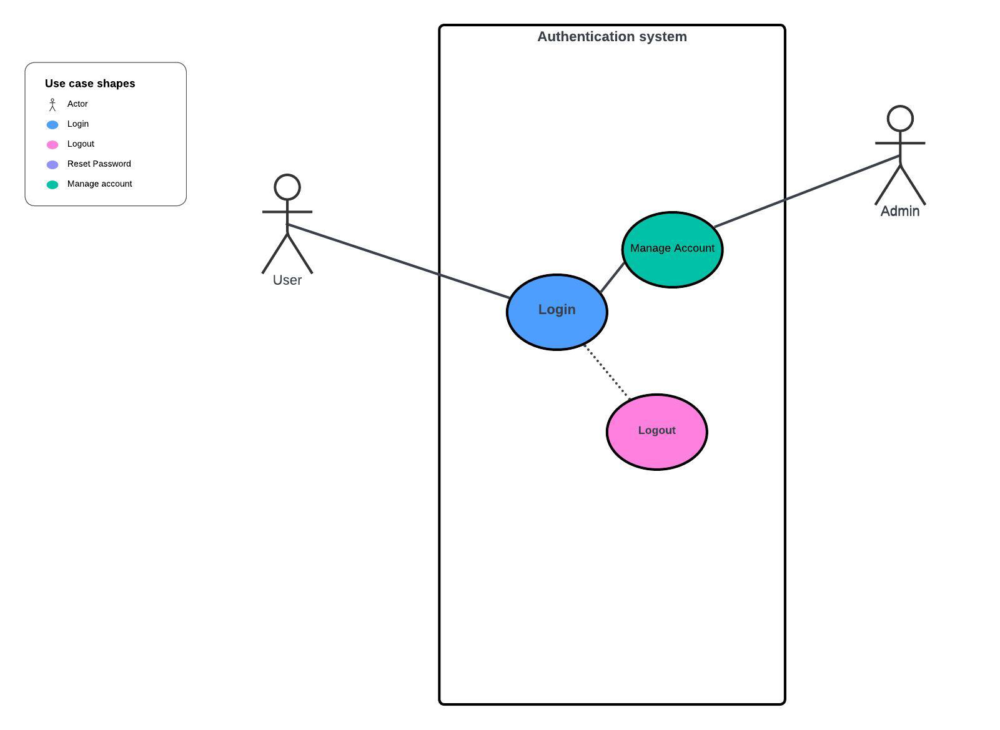

The use case diagram created using lucid chart represents the functionalities of an authentication system from the user’s perspective. It shows two types of actors, ‘User’ and ‘Admin’, who interact with the system. The ‘User’ can perform actions such as ‘Login’ and ‘Logout’ and ‘Reset Password’. The ‘Admin’ has the capability to ‘Manage Account’, which may involve administrative privileges over accounts. Each use case is represented as an oval within the system. The diagram is clear and straightforward, illustrating the basic functionality available to each type of actor within the system.

Activity Diagram:

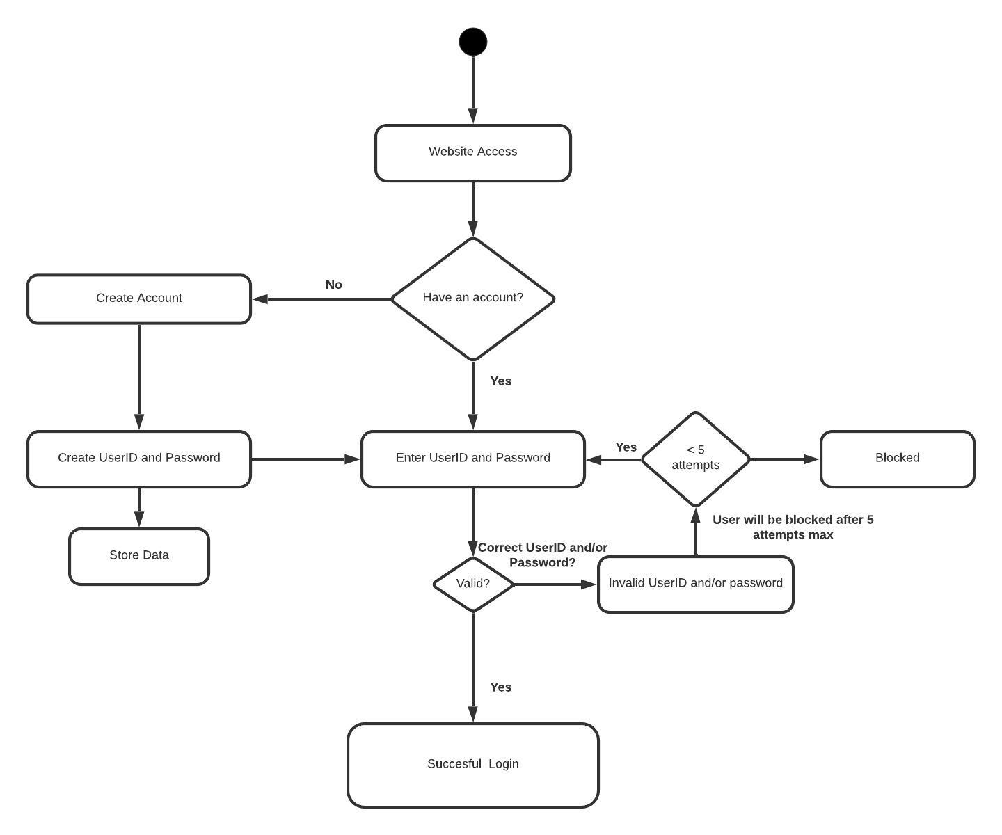

The Diagram represents the process a user follows to gain access to a website. Initially, the user is presented with a choice: if they don’t already have an account, they are directed to create one by providing a new UserID and Password which the system then stores. If the user already has an account, they must enter their existing credentials. The system then checks if the UserID and password are correct; if they are correct the user is logged in successfully. However, if credentials are incorrect, the user can either try again or opt to reset their credentials. In addition, the diagram includes a safeguard where if a user enters incorrect credentials five times, their account is blocked to prevent unauthorized access.

The diagram represents the events that actors generate in chronological order. It illustrates the behavior of the system by showing how the actors and a set of objects interact over time. It is essentially the activity diagram but on a chronological basis and how the actors act and respond to interacts with the business server and database server through interacting with the components of the system.

